Macramé
Macramé was once thought to be left behind in the 70's - with avocado green bathrooms and nylon carpets the trend has really had a big come back in recent years! It's a really versatile craft; it's inexpensive, only a few materials are needed, plus most children and adults can get to grips with the basics! Macramé can make the perfect plant hangers, wall hangings, dream catchers or even place mats and table runners.
Macramé is a great Mother’s day gift - once you have mastered the basic knots, the skies the limit and you’ll soon be addicted! Whilst you could purchase your own Macramé there is nothing quite like the satisfaction of making something yourself. There are lots of ideas online or you could invest in a book such as 'Macramé' by F Zedenius. Here’s a step-by-step guide from the book to get you started:

Plant hanger

Materials
42m (46yds) of twined 4mm (3/16in) cotton rope
4 wooden beads, 2-2.5cm (3/4-1in) diameter with 6-10cm (1/4-3/4in) diameter hole
Measuring tape

Knots used (knot methods at end)
Square knot (SK)
Right- twisting half square knot (RTHSK)
Alternating square knot (ASK)
4ply crown knot (4-CK)
Wrap knot (WK)

Preparation
Cut the following;
4 cords each 3.4m (3 ¾ yards) long
2 cords each 6m (6 5/8 yards) long
1 cord 7.4m (8 1/8 yards) long (extra-long to make the top loop.
1 cord 8.6m (91/2yd) long (extra-long to make the top loop and the wrap knot at the end)

Instructions
- Take the 4,3.4m (3 ¾ yd.) cords and the 2, 6m (6 5/8 yd.) cords and lay them on the floor parallel to each other, with the middle point of each cord aligned. These cords will be used as filler cords in the top loop. Take the 2 remaining cords and place them on either side of the others, so both of them have one end aligned with the top end of the 2 6m (6 5/8 yd.) long cords. These will be used as the working cords for the loop.
- Use the longer end of each working cord, which is not aligned with the other cords to tie a line of 11 square knots (SK) to make a sennit placed at the centre of the bundle of filler cords. Make sure you use the long ends of the working cords and that the other ends remain aligned with the top ends of the 6m (6 5/8 yds.) filler cords.
- Bend the sennit into a loop. Use the long end of the working cords to tie a spiral of right-twisting half square knots (RTHSK) around all the other cords.. The spiral should be about 6cm (2 3/8 in) long or about 10 to 15 square knots.
- Divide the cords into 4 bundles, each containing 2 long cords and 2 short cords. Begin by tying each bundle into a sennit, each with 15 square knots.
- Drop about 10cm (4in) and tie a square knot in each of the bundles of cord. Thread a bead onto the 2 filler cords of each bundle, then tie another square knot underneath the bead.
- Under each square knot tie a spiral of right- twisting half square knots (RTHSK) each about 13cm (5 1/8 in) long or 20 to 24 half square knots.
- To make the net, tie 2 rows of alternating square knots (ASK), alternating the filler cords and working cords. Place the knots with about 6-7cm (2 3/8-2 3/4in) of space above and below them.
- To tie the cords together at the base, make a 4ply crown knot (4 CK), using the 4 sets of cords as working cords as shown in the illustration. Place your fist on a table with the tail of the plant hanger held upside down, and lay the cords down to make it easier to work the crown knot. Place the crown knot about 6-7cm (2 3/8-2 ¾ in) from the square knots above it Tie 5 to 6 rounds of the crown knot.
- Take the longest remaining cord and tie 5-6cm (2-23/4in) long wrap knot (WK) around the other cords.

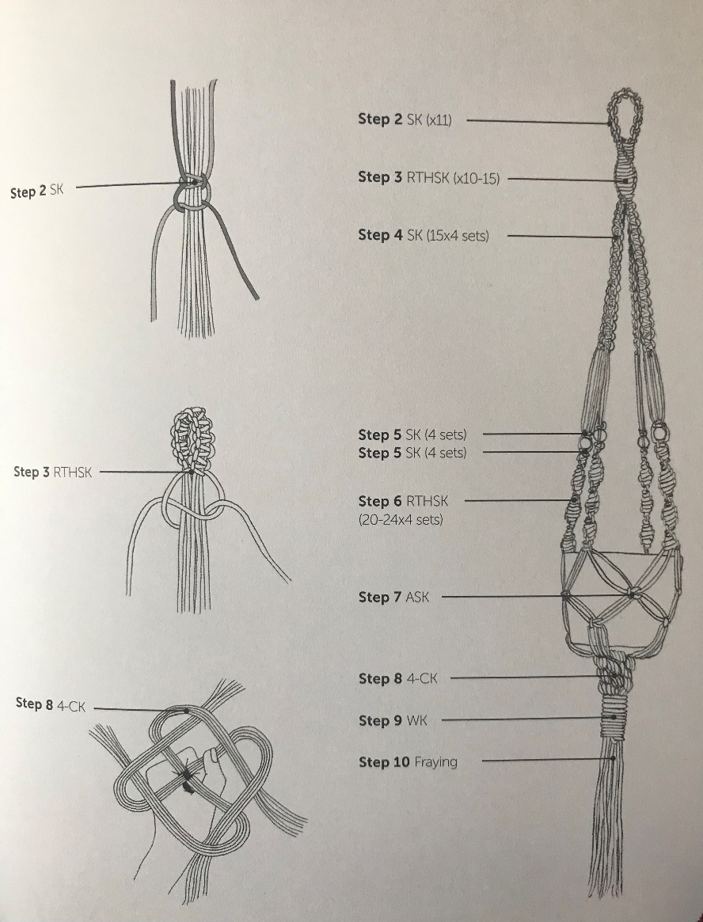

Knot methods

Square Knot Square knots (SK) are commonly created using two filler cords in the centre, with working cord on each side. The knots can face left or right, depending on the sequence in which they are tied. This is one of the most common macramé knots used in most patterns. By alternating filler and working cords on rows of square knots, you are able to create a net like pattern.

Right twisting half square knot (RTHSK) The right twisting half square knot is created by repeatedly tying only half of the right facing square knot. Pass the cord B to the left over the filler cords, forming a loop, and behind cord A. Move cord A behind the filler cords and pass it up through the loop from behind. Pull cord A gently to the right and B gently to the left, while holding the filler cords straight.
Pass cord A to the left over the filler cords, forming a loop, and behind cord B . Move cord B behind the filler cords and pass it up through the loop from behind. Make sure that you pull the working cords equally tight. The knot should look the same front as back.

As you repeat steps 1-2 the spirals will form.
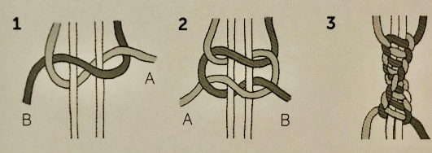

Alternating square knot (ASK) Tie a row of square knots. On the 2nd row use the outer working cord of each pair of adjacent square knots as the filler cords and the nearest pair of filler cords as the working cords, so that the second row of square knots will be offset.

Tighten each knot, placing it close to the first row to create a fine net, or position it further apart from the first row to create a looser net.
Continue alternating the filler and working cords used to tie the knots on every other row.

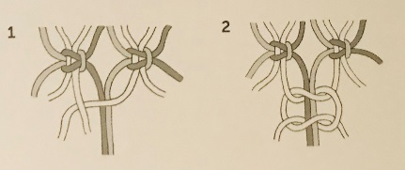

4 ply crown knot (4-CK) Lay out your 4 strands in 4 different directions. You can use a knot to hold them together in the centre otherwise hold them with your non- dominant hand, using the other to tie the knot. If you use 2 strands lay them across each other to form a cross.

Take any of the strands and fold it round over the strand next to it, creating a loop. Then take the second strand and fold it around over both the first and the third strand.

Take the third strand and fold it over both the second and the fourth strand. For the fourth strand, fold it over the third then the first strand and pass it through the loop formed by the first strand. Gently pull each strand, one at a time, to tighten the knot.
Repeat steps 2-3 until your crown knot is the desired length.

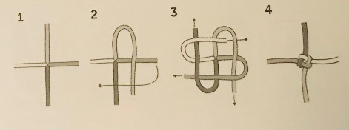

Wrap knot (WK) Gather the filler cords together and place the working cord on top folded in a U shape. Begin wrapping one end of the working cord around the cords, staring at the top. For the first lap, hold the working cord in place with one hand (where the working cord passes over itself0 while wrapping with the other hand. As you continue you can let go and turn the bundle around as you wrap, so you can make sure that all laps are placed neatly together.

Stop wrapping when you see about 1 cm (1/8in) of the folded loop left. Pass the working cord through the loop from the front.

Pull the top of the working cord so that the loop slides up behind the wrapping.
